**Team Members:** Chiemela Nwoke, Jai Mistry, Abdul Haseeb Arif

Project Deliverable 2 update

1st Diagram

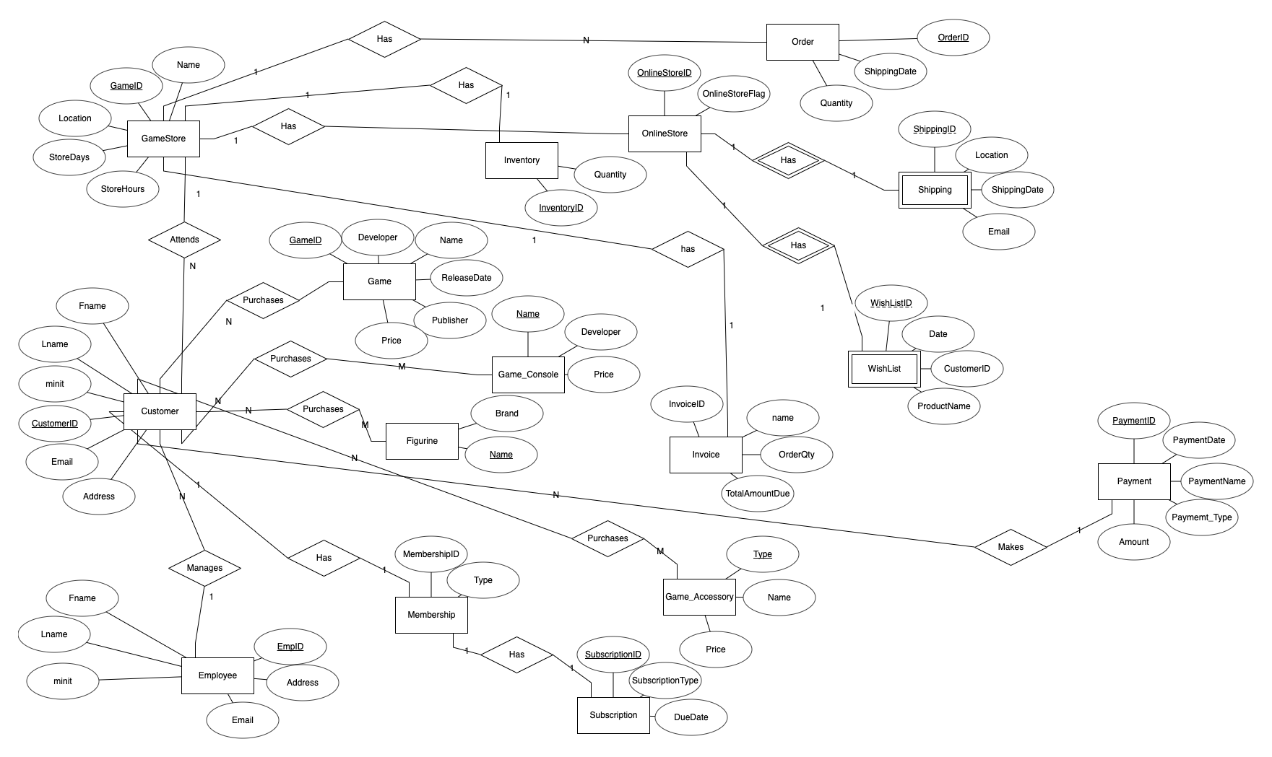

**2ND Iteration Diagram**

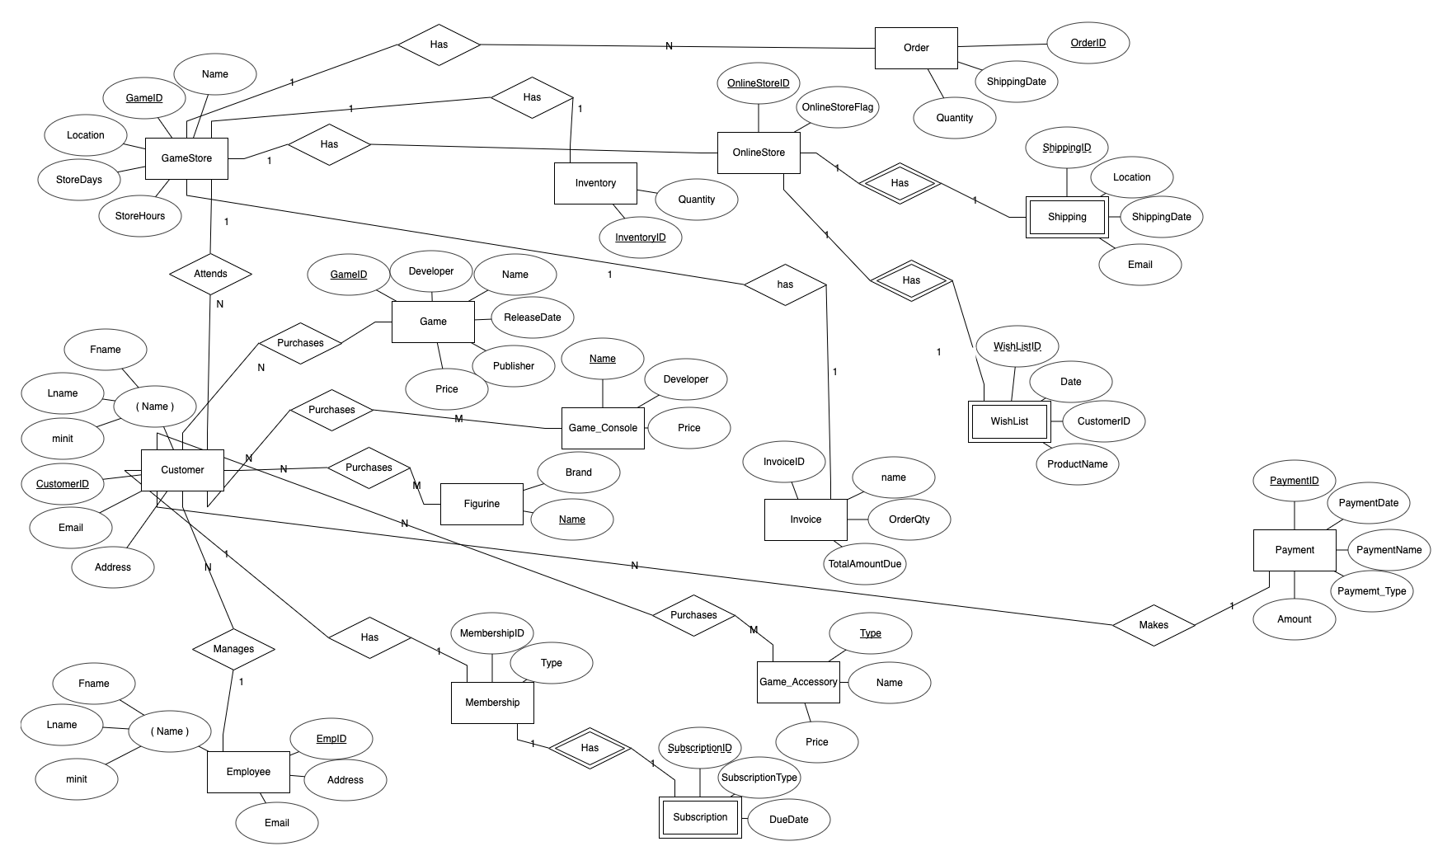

What was chaged:

* Made “Name” attributes composite with Lname, Fname and MINIT for both Customer and Employee entities.
* Made Subscription entity weak entity with parent entity of Customer

Final Diagram

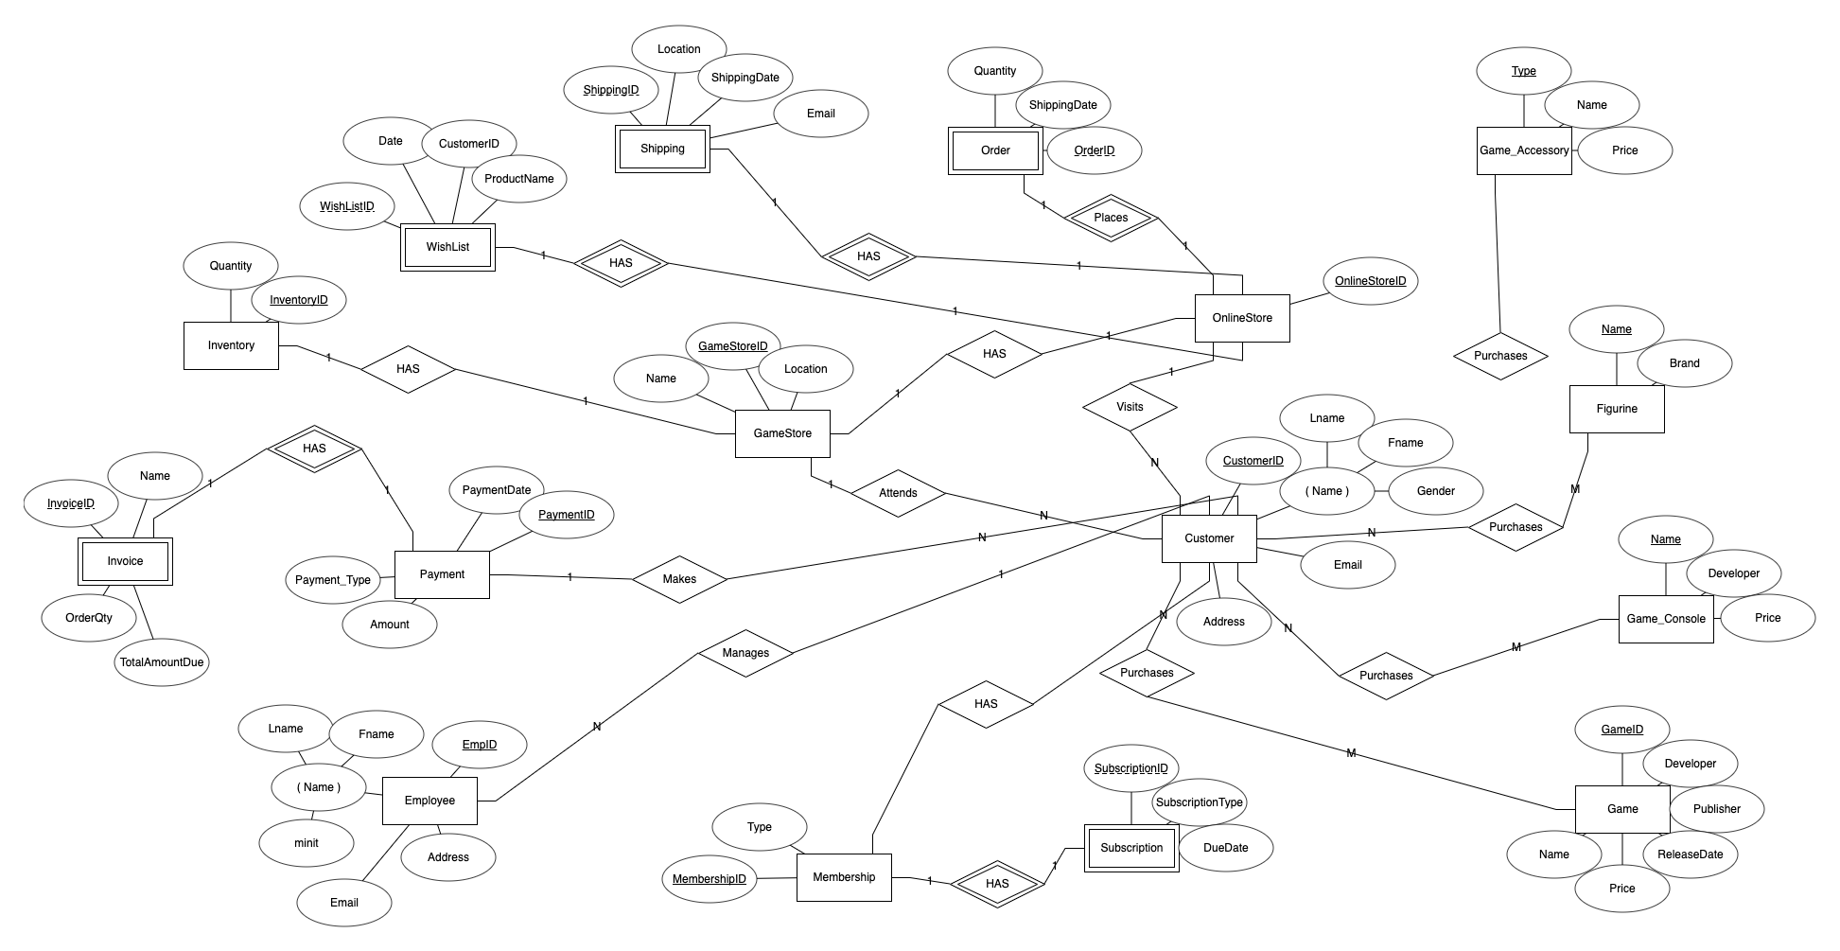

What was changed:

* changed relatiohship between Invoice and GameStore to “Has” between Invoice and Payment with 1 to 1 relationship and made invoice weak entity to Payment
* changed order relationship to onlinestore because customers place orders through the online store based on the requirment.
* Deleted StoreDays and StoreHours attributes of GameStore because it wasn’t making sense.

Rational Based on requirement

GameStore has relationship to inventory because inventory shows the quantity of products in stock. It also has relationship with customer and OnlineStore. Orders are only placed through the onlineStore based on the requirement. WishList and Shipping are only available through onlineStore. Subscriptions are done through the membership. Game, Game_Console, Game_Accessory and Figurine are all connected to customer because customers purchase these products. Invoice is only related to payments.